|  |
| --- |
| 新东方在线英语学习 |
| 新概念 2 册 |
| Lesson47 |



扫一扫。更多有趣的英语资讯。

# Lesson 47 单词讲解

1. thirsty adj. 贪杯的 口渴的

I am thirsty. / I feel thirsty.

The man was thirsty for power / knowledge / success. hungry adj. 饿的

1. ghost n. 鬼魂

a creepy ghost story

1. haunt v. (鬼)来访（主动），闹鬼（被动）

People say ghosts haunt the old house. The house is haunted (by the ghosts).

v. (不愉快的事情)萦绕心头

If something unpleasant haunts you, try to ignore it and move on.

如果有不愉快的事纠缠你，试着忽略他和继续往前走

She was haunted by bad feelings night and day.

1. block v. 堵

The highway was blocked by a few trucks.

The clouds blocked his view of the mountains. n.拥堵 大楼 街区

traffic block / jam a block of flats

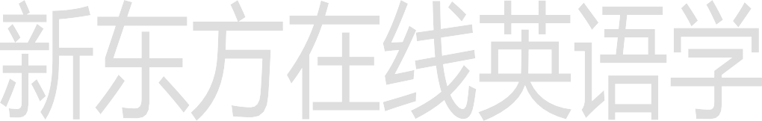

She walked three blocks down the main street.

1. furniture n. 家具

a piece of furniture

1. shake v. 摇动

shake shook shaken

shake one’s head

摇头

shake hands with sb.

握手

[suggest](http://dict.cn/suggest.htm) doing sth accept [ək'sept] v.接受

Receive 接收

# Lesson 47 课文&语法讲解

1. A public house which was recently bought by Mr.Ian Thompson is up for sale.

a public house

be up for sale

which was recently bought by …

定语从句 被动语态

1. Mr. … is going to sell it because it is haunted.

一般将来时 被动语态

1. He told me that he could not go to sleep one night …

间接引语 （宾语从句）

1. … he found that the doors had been blocked by chairs and the furniture had been moved.

宾语从句 过去完成时的被动语态

Though Mr. … had turned the lights off before he went to bed, they were on in the morning.

过去完成时 ／ 一般过去时

1. He also said that he had found five empty whisky bottles which the ghost must have drunk …

一般过去时 ／ 过去完成时宾语从句 定语从句must have done 推测过去

1. When I suggested that some villagers must have come in for a free drink, Mr. … shook his head.

宾语从句

推测过去 must have done a free drink

shake one’s head

1. The villagers have told him that they will not accept the pub even if he gives it away.

间接引语 （宾语从句）

even if 即使

# Lesson 47 知识拓展

复习前两单元内容：

句子的分类 （按照结构划分）

1. 简单句
2. 并列句
3. 复合句简单句

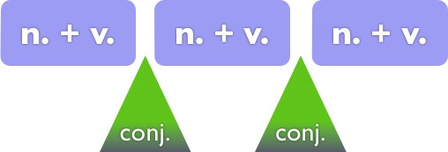n. + v



主语

谓语

句子的分类 （按照结构划分）

1. 简单句
2. 并列句
3. 复合句

句子的分类 （按照结构划分）

* 1. 简单句
  2. 并列句
  3. 复合句 ＝主句＋从句

名词性从句 （主/宾/表/同位） 定语从句

状语从句

* Look at those clouds!
* Don’t worry. it rains, we’ll still have a great time.
  + 1. Even if
    2. As though
    3. In case
    4. If only (2012 北京 21)
* Look at those clouds!
* Don’t worry. it rains, we’ll still have a great time.

1. Even if
2. As though
3. In case
4. If only (2012 北京 21)

